# OpenSUSE-freeradius setup:

## OpenSuse:

Install freeradius through yast:

### Clients.conf:

10.10.1.1 is to test the radius connection

The switch is configured on 192.168.11.1

### Users file:

Add mac address to users and preconfigure

## Switch config

### Basic config:

ena

conf t

hostname ca-mab-switch

ip domain-name pieter.local

crypto key generate rsa

2048

line vty 0 15

transport input ssh

login local

exit

username admin password cisco

enable secret cisco

end

enable

configure terminal

vlan 410

name Servers

exit

vlan 411

name Infrastructure

exit

vlan 412

name A-Users

exit

vlan 413

name B-Users

exit

vlan 414

name Externals

exit

vlan 415

name IP-phones

exit

interface vlan 410

ip address 192.168.10.1 255.255.255.0

no shutdown

exit

interface vlan 411

ip address 192.168.11.1 255.255.255.0

no shutdown

exit

interface vlan 412

ip address 192.168.12.1 255.255.255.0

no shutdown

exit

interface vlan 413

ip address 192.168.13.1 255.255.255.0

no shutdown

exit

interface vlan 414

ip address 192.168.14.1 255.255.255.0

no shutdown

exit

interface vlan 415

ip address 192.168.15.1 255.255.255.0

no shutdown

exit

ip dhcp excluded-address 192.168.10.1 192.168.10.10

ip dhcp pool VLAN410

network 192.168.10.0 255.255.255.0

default-router 192.168.10.1

dns-server 8.8.8.8

exit

ip dhcp excluded-address 192.168.11.1 192.168.11.10

ip dhcp pool VLAN411

network 192.168.11.0 255.255.255.0

default-router 192.168.11.1

dns-server 8.8.8.8

exit

ip dhcp excluded-address 192.168.12.1 192.168.12.10

ip dhcp pool VLAN412

network 192.168.12.0 255.255.255.0

default-router 192.168.12.1

dns-server 8.8.8.8

exit

ip dhcp excluded-address 192.168.13.1 192.168.13.10

ip dhcp pool VLAN413

network 192.168.13.0 255.255.255.0

default-router 192.168.13.1

dns-server 8.8.8.8

exit

interface range fa0/3 - 24

switchport mode access

spanning-tree portfast

exit

int vlan 411

ip address 192.168.11.1 255.255.255.0

exit

interface G0/1

switchport mode access

switchport access vlan 411

### Mab-config:

enable

conf t

aaa new-model

aaa group server radius RAD-MAB

server name ca-mab-01

aaa authentication dot1x default group RAD-MAB

aaa authorization exec default local

enable

conf t

aaa new-model

aaa group server radius RAD-MAB

server name ca-mab-01

aaa authentication dot1x default group RAD-MAB

aaa authorization exec default local

aaa authorization network default group RAD-MAB

ip radius source-interface Vlan411

radius server ca-mab-01

address ipv4 192.168.11.3 auth-port 1812 acct-port 1813

automate-tester username dummy

key rad123

interface range fa0/3-12

switchport mode access

authentication event server dead action authorize vlan 414

authentication event server alive action reinitialize

authentication port-control auto

mab

spanning-tree portfast

ip radius source-interface Vlan411

radius server ca-mab-01

address ipv4 192.168.11.3 auth-port 1812 acct-port 1813

automate-tester username dummy

key My;Secret

interface range fa0/3-12

switchport mode access

authentication event server dead action authorize vlan 414

authentication event server alive action reinitialize

authentication port-control auto

mab

spanning-tree portfast

Run the switch configs

# NPS windows config:

### Install the Network Policy and Access Services:

### Add switch as network policy client:

The secret is set to the same secret as the switch

### Make Server Domain Server:

Add the mac address to the Calling Station ID

# 802.1x

## Windows-server

### Create new user group and user:

### Network Policies

### Connection-request policy:

## Switch -config:

enable

conf t

aaa new-model

aaa group server radius RAD-MAB

server name ca-mab-01

!

aaa authentication dot1x default group RAD-MAB

aaa authorization exec default local

aaa authorization network default group RAD-MAB

ip radius source-interface vlan411

radius-server attribute 8 include-in-access-req

radius-server host 192.168.11.3 key "rad123"

radius server ca-mab-01

address ipv4 192.168.11.3 auth-port 1812 acct-port 1813

key rad123

exit

dot1x system-auth-control

radius server ca-mab-01

address ipv4 192.168.11.3 auth-port 1812 acct-port 1813

automate-tester username dummy

key rad123

interface range fa0/13-24

switchport mode access

authentication event server dead action authorize vlan 410

authentication event server alive action reinitialize

authentication order dot1x mab

authentication priority dot1x mab

authentication port-control auto

mab

dot1x pae authenticator

spanning-tree portfast

end

### Proof it works:

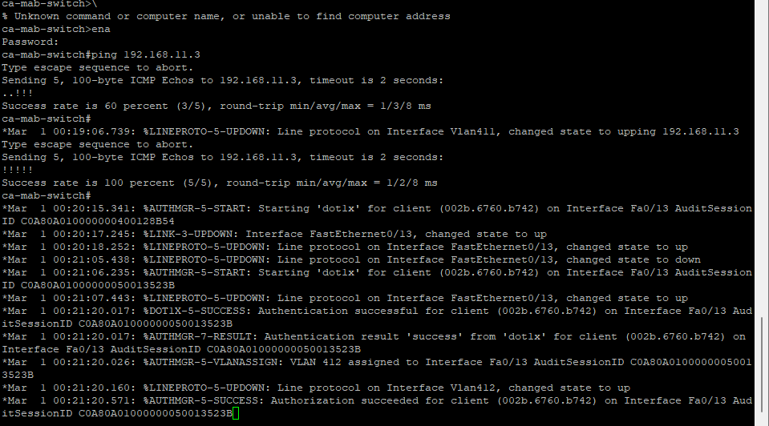

# MAB-fallback

Change the password policy:

Create a new user with the mac address as username and password:

New network policy for MAB:

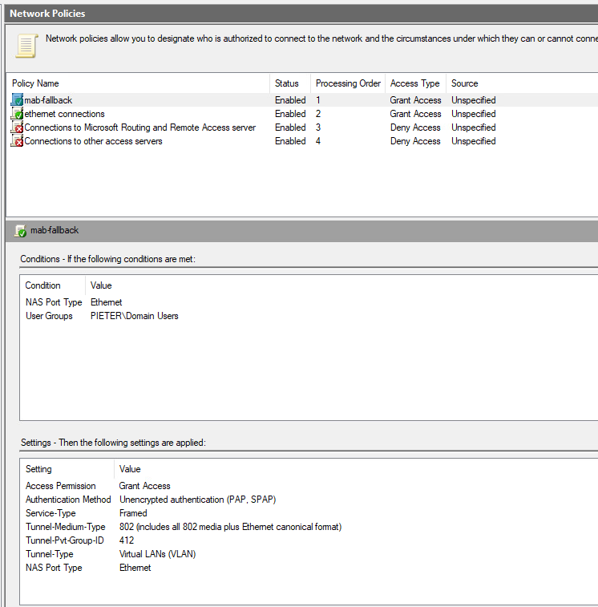

Switch config was done earlier in the exercise.

Created user for Docent computer:  
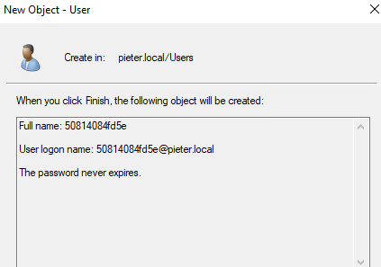

# Network schema

